- Navigate to the following URL: https://www.lcbo.com/en/products/wine/red-wine#t=clp-products-wine-red_wine&sort=relevancy&layout=card
- Find the Collection of Cards on this page
  - Find the relevant link (url) that links to the detail page for each wine listing
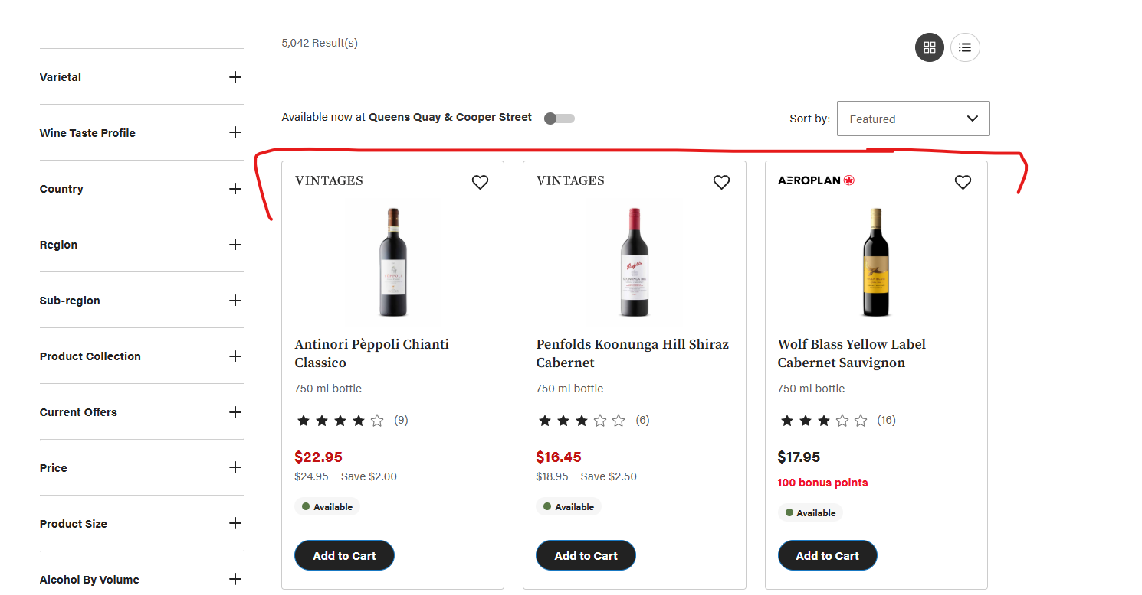
- Store the URLs for detail scraping
- For Each Wine, navigate to the detail and:
  - Capture All Details as noted below (See later steps for Record Layout)
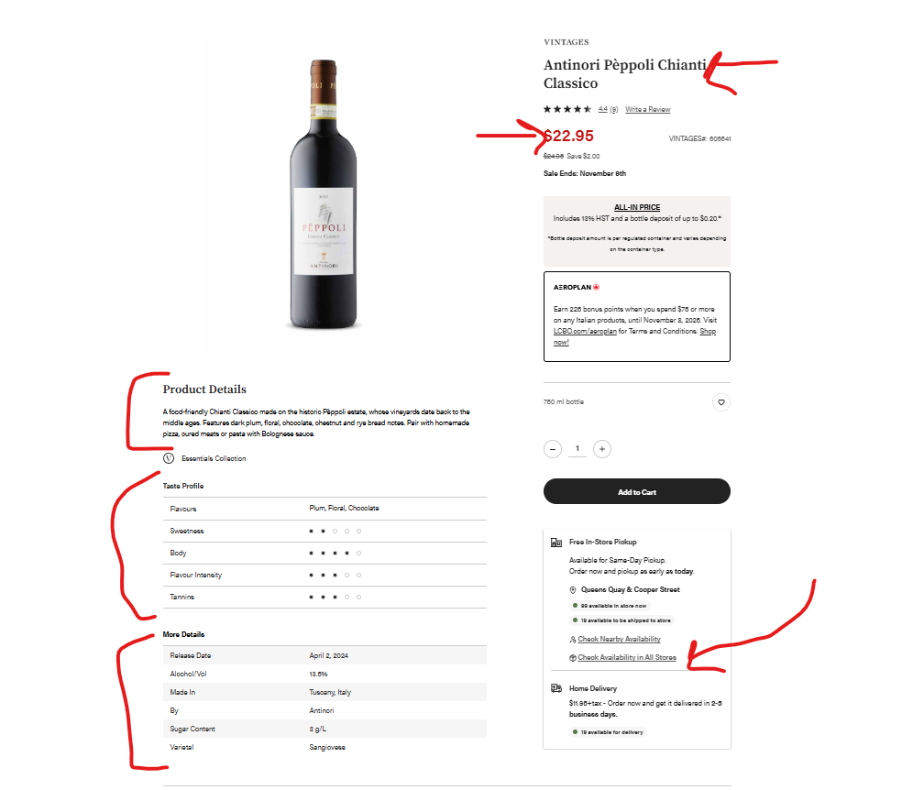
- For each wine, navigate to the availability in all stores (see screenshot above)
- Parse and Capture details of the Wine, and relevant details related to Wine, City, Address and Quantity
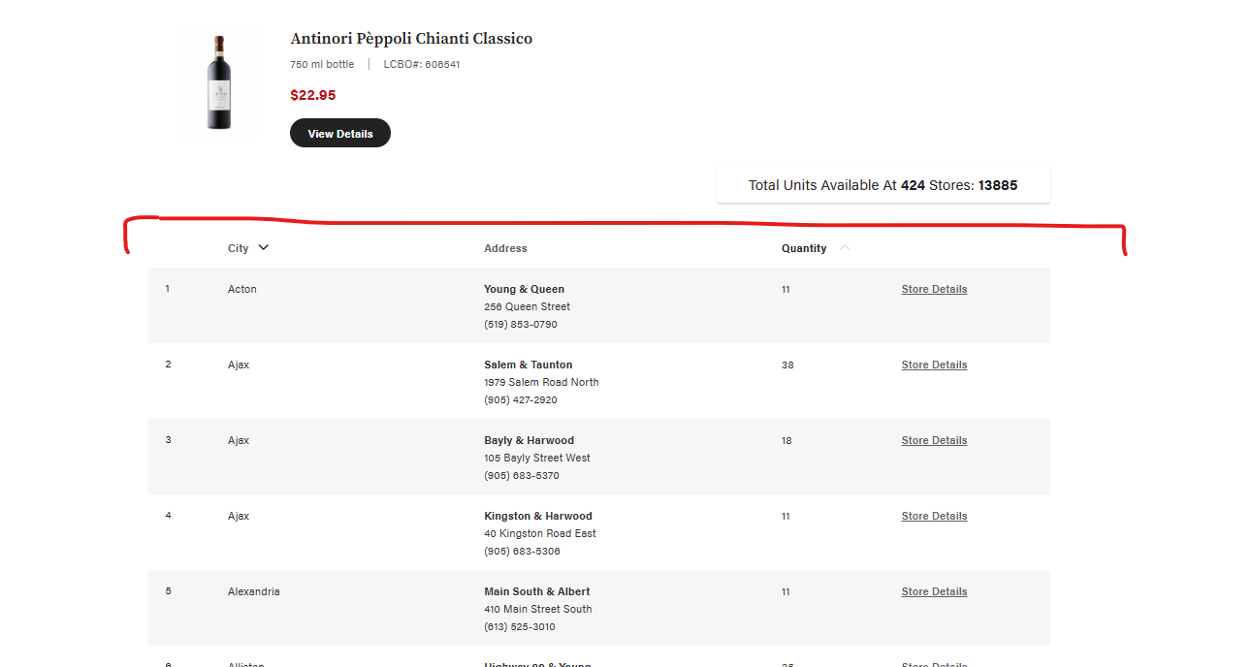

- Write two Sheets to an Excel Workbook for each collection of data
  - If you do not have excel write two csv files with the appropriate layout as below
